**Lecture 2: AI Agents & Environment Properties**

**Question:** Classify the following environments and provide examples:

a) Chess game (Fully Observable)(Deterministic)(Sequential)(Static)(Discrete)(Multi-agent)

b) Self-driving car navigation (Partially Observable)(Stochastic)(Sequential)(Dynamic)(Continuous)(Multi-agent)

c) Email spam filter (Fully Observable)(Stochastic)(Episodic)(Static)(Discrete)(Single-agent)

d) Crossword puzzle (Fully Observable)(Deterministic)(Sequential)(Static)(Discrete)(Single-agent)

**Question:** Match each agent type with its appropriate example:

1. Simple Reflex Agent => Vacuum Cleaner
2. Model-Based Reflex Agent => Self-Driving Car
3. Goal-Based Agent => Google Maps
4. Utility-Based Agent => Uber AI
5. Learning Agent => AI Chess Player

**Lecture 3: Solving Problems by Searching Algorithm**

**Problem 1:**

**Question:** For the Eight Puzzle problem, define:

a) States => Tile (square) locations

b) Initial state => One specific tile configuration

c) Operators => Move blank tile left, right, up, or down

d) Goal => Tiles are numbered from one to eight around the square

e) Path cost => Cost of 1 per move

**Problem 7:**

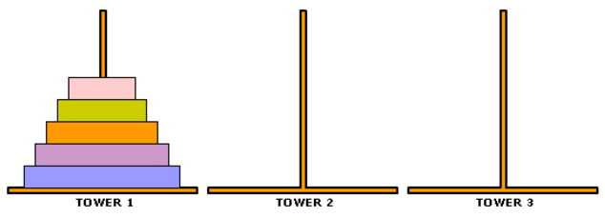

**Question:** For the Towers of Hanoi problem with n disks, what is the minimum number of moves required? Calculate for 1, 2, 3, and 4 disks.

**Answer:** Formula: 2n - 1

* 1 disk → 1 move
* 2 disks → 3 moves
* 3 disks → 7 moves
* 4 disks → 15 moves

**Breadth-First Search (BFS)**

[ 0, 1, 2, 3, 4 ]

[[1,2], [0,2,3], [0,1,4], [1,4], [2,3]]

0

/ \

1–––– 2

/ \

3 –––––– 4

[ 0, 1, 2, 3, 4]

**Greedy Best-First**

**Final Path:** A → B → C → E → G → F